Java SE Project

Hospital Management System Application

***Configure SMS APIs Documentation***

1. ***BulkSMS API :***



[*https://www.bulksms.com/products/sms-api.htm*](https://www.bulksms.com/products/sms-api.htm)

1. Go to the **official website** using the given **link above** which will lead you to this page.
2. Now click on **Sign up for free today!** Button Now you will be redirected to the **Register page.**

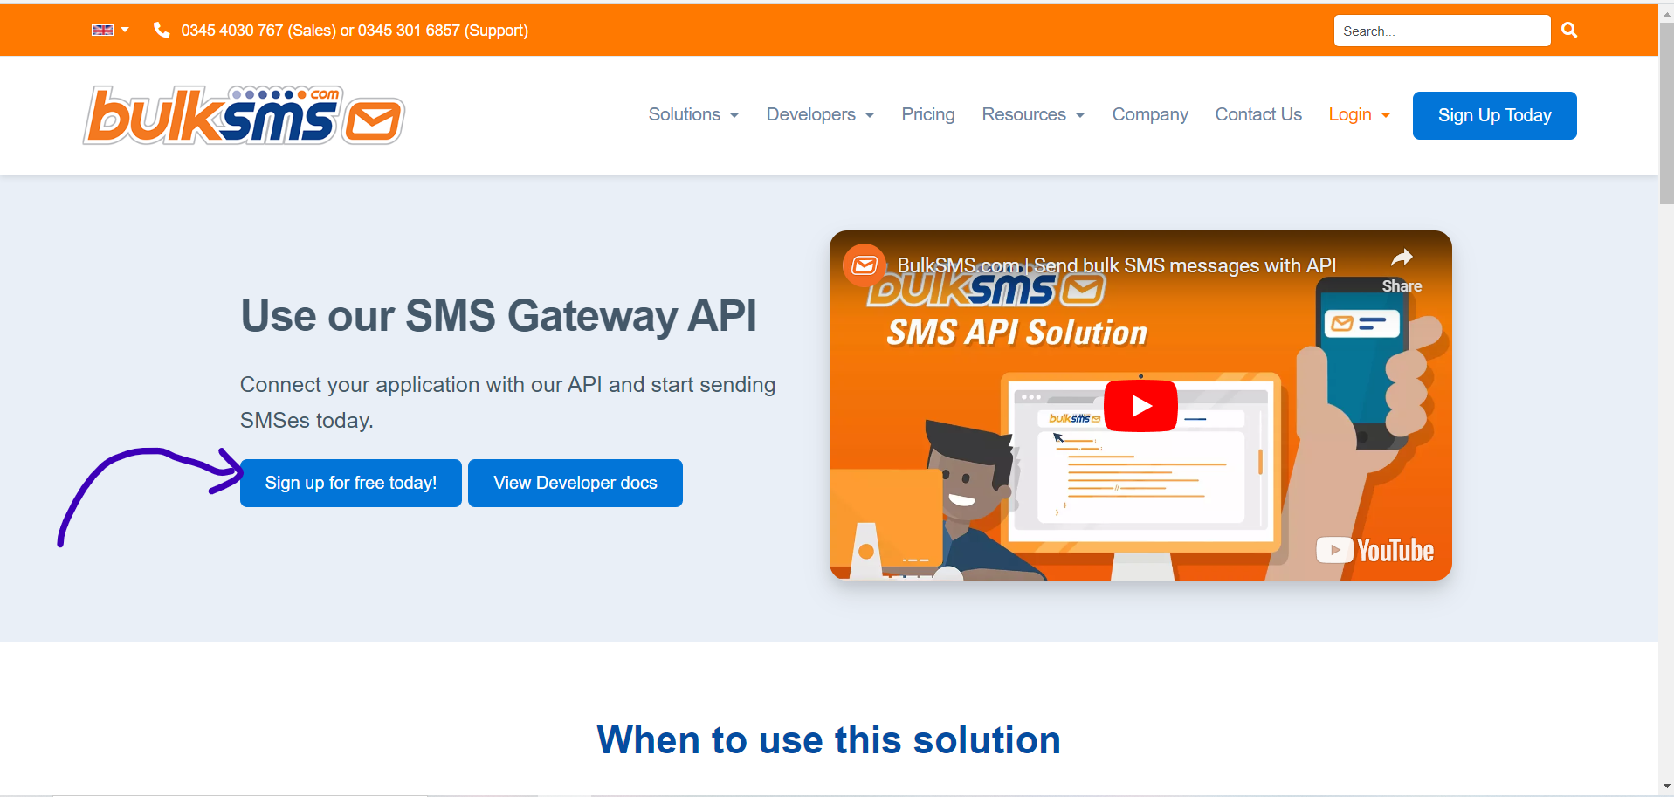

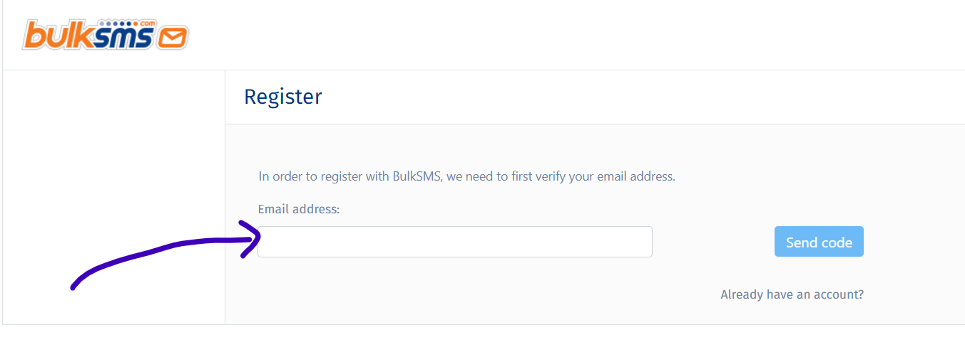

1. Enter your **email id** and **verify it** with **the otp** then you will be redirected to next page.

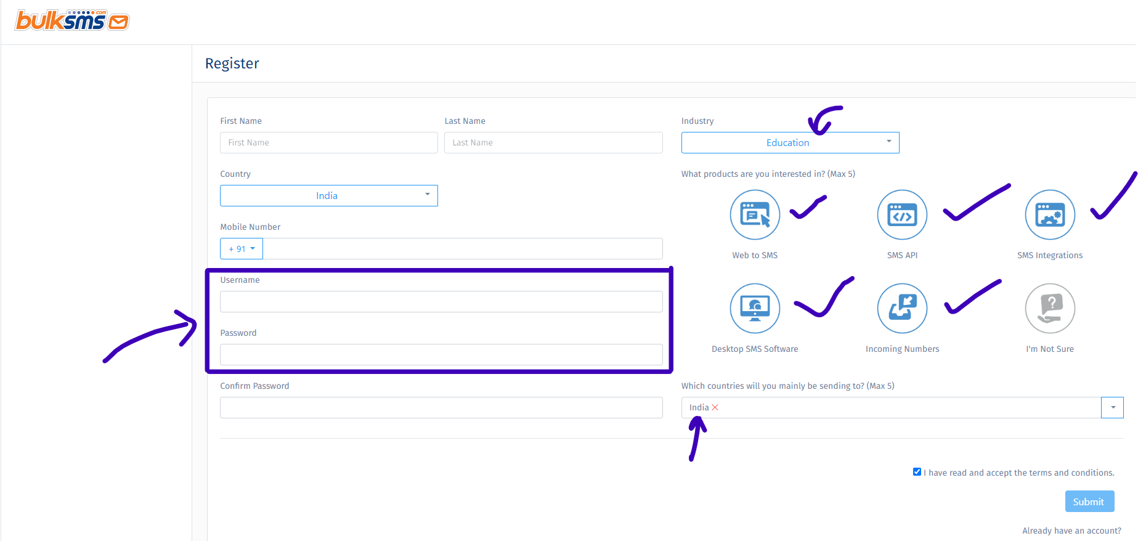

1. Fill all the details and select the options as given in the image.
2. **Most important part remember the username and the password.**
3. You will **need** them while **configuring the API.**

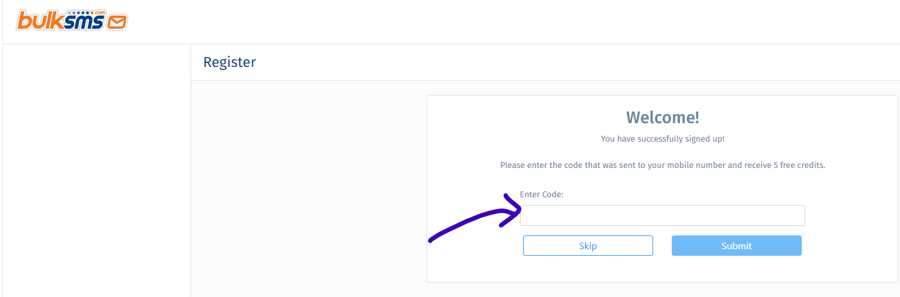

1. After completing the registration you will redirected to this page.
2. **Do not Skip this page otherwise you won’t be able to use this API.**
3. Just **enter** the **OTP sent** to your **mobile** and click on **Submit button.**
4. That’s it.
5. Now **Open** the **File Named** as **BulkSmsApi.java**
6. Paste your **username** and **password** in it.

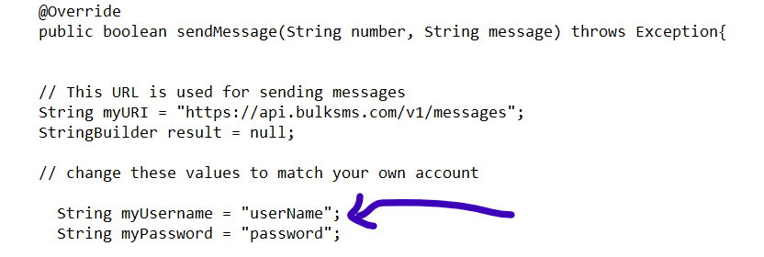

1. ***2Factor Sms Api :***



[*https://2factor.in/v3/free-bulk-sms-service-trial/index.php*](https://2factor.in/v3/free-bulk-sms-service-trial/index.php)

1. Go to the **official website** using the given **link above** which will lead you to this page.
2. Fill all the details and verify it, Now click on **Register** Button.

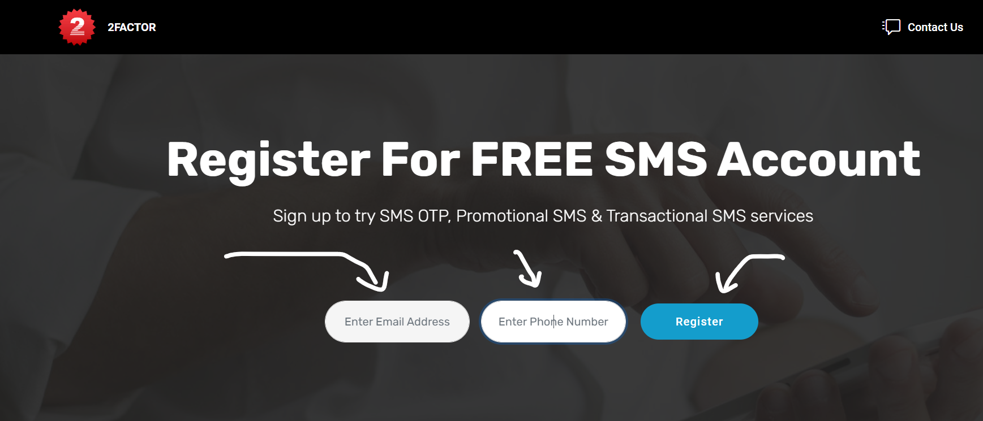

1. Then **login** to **your account**.
2. Your **username** and **password** has been **sent** to **your email address.**

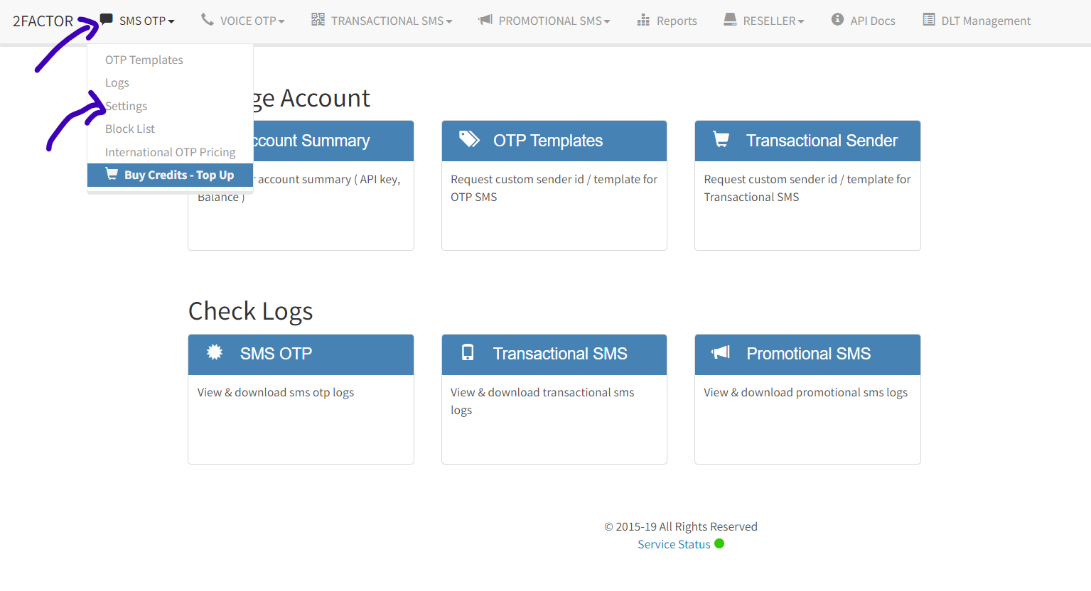

1. After clicking on **setting** you will **find your account details** and **api key**
2. **Copy** your **api key**
3. Open the **file named** as **TwoFactorSmsApi.java**
4. And **paste** into it.

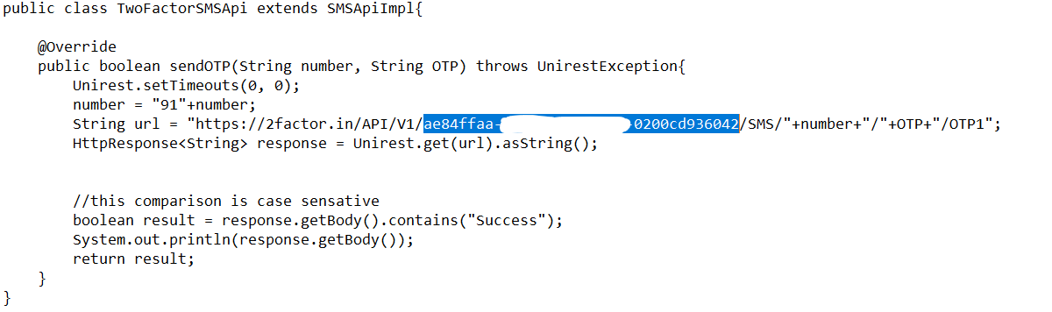

**Thank You**